Exercise Solution

Task
Change Celsius to Kelvin: Modify the program to convert a temperature from Celsius to Kelvin instead of Fahrenheit. The formula for conversion is: K=C+273.15K = C + 273.15K=C+273.15 (You can round 273.15 to 273 for simplicity.)
Add a Welcome Message: Add a welcome message at the beginning of the program to greet the user before asking for the Celsius temperature.
Display Celsius Input: After the user enters the Celsius temperature, display the input back to the user before showing the converted value.

INPUT:

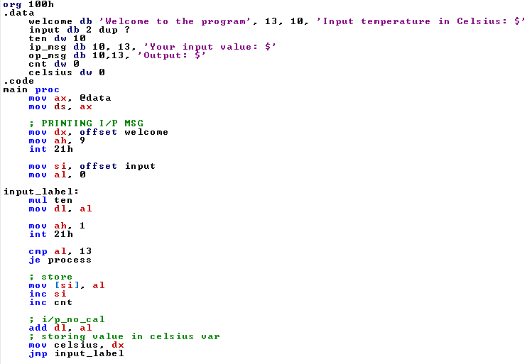

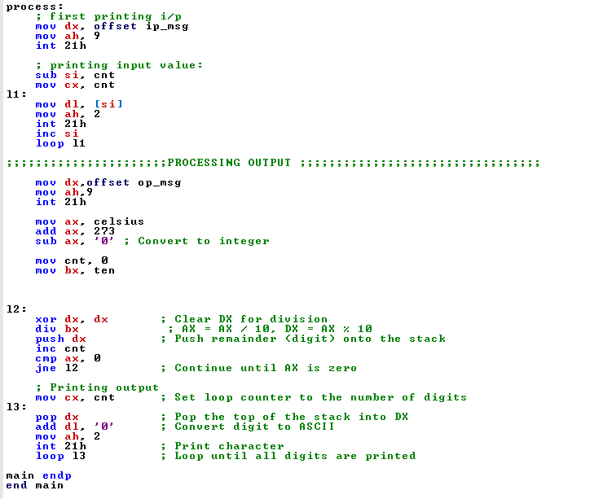

OUTPUT:




